Auto Pillow IOS SDK Reference
V1.0
Author: Michael
2019/08/23

Change log
Date | Log | Author
2019-08-23 | Create | Michael
2021-09-26 | Realtime Temperture invalid | San

Internal document. Do not pass away

TOC

Change log 1
TOC 2
IOS SDK Intro 5
1. Function and Purpose 5
Integration 5
1 . framework 5
2 .Integration 5
API 7
How to call method 7
1. Scan Bluetooth 7
Description 7
Parameters 7
2. Stop Scan 8
Description 8
Parameters 8
3. Connnect Device 8
Description 8
Parameters 8
4. Get Battery 9
Description 9
Parameters 9
5. Get Device Version 9
Description 9
Parameters 10
6. Get Collection Status 10
Description 10
Parameters 10
7. Get Sleep Data (Real-time) 10
Description 10
Parameters 10
Notification 11
8. Stop Getting Sleep Data 11
Description 11
Parameters 11
9. Get The Signal Strength (Real-time) 11
Description 11
Parameters 11
Notification 12
10. Stop Getting The Signal Strength 12
Description 12
Parameters 12
11. Get Sleep Report 12
Description 12
Parameters 13
12. Firmware Update 13
Description 13
Parameters 13
13. Get environment data 13
Description 13
Parameters 14
Object definition 14
DeviceCode 14
SLPTransforCallback 14
Description 14
Method 14
Parameters 14
SLPDataTransferStatus 15
SLPPeripheralInfo 15
Description 15
Fields 15
PillowDeviceInfo 15
Descrption 15
Fields 16
PillowBatteryInfo 16
Description 16
Fields 16
PillowDeviceVersion 16
Description 16
Fields 16
PillowCollectionStatus 17
Description 17
Fields 17
PillowRealTimeData 17
Description 17
Fields 17
PillowOriginalData 18
Description 18
Fields 18
SLPHistoryData 18
Description 18
Fields 18
HistoryDataSummary 19
Description 19
Fields 19
HistoryDataDetail 19
Description 19
Fields 20
HistoryDataAnalysis 20
Description 20
Fields 21
HistoryDataScoreDeduction 24
Description 24
Fields 24
Pillow_ScoreDeductibleTypes 24
Description 24
Fields 24
PillowUpgradeInfo 25
Description 25
Fields 26

IOS SDK Intro

Function and Purpose
Pillow SDK,launched by Sleepace, is a software development kit for fast Internet APP development on iOS platform. The SDK encapsulates the communication process between APP and hardware, and provides functions such as device configuration, device control and data query. Using the SDK, users do not need to care about complex communication protocols and the underlying implementation, only need to focus on the APP interaction and business level.

Integration

1 . framework

framework | Description
BluetoothManager.framework | SDK Core
Pillow.framework | Pillow Core
SLPCommon.framework | Common

2 .Integration
1: add libc++.tbd in the Link Binary with Libraries
2: Import BluetoothManager.framework, Pillow.framework，SLPCommon.framework
Like this：
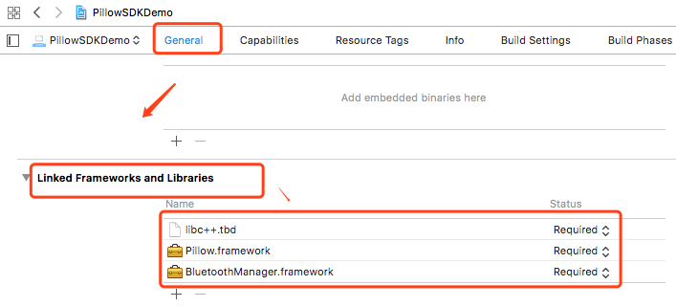
3: Setting other linker flags
-force_load $(SRCROOT)/PillowSDKDemo/BluetoothManager.framework/BluetoothManager
-force_load $(SRCROOT)/PillowSDKDemo/Pillow.framework/Pillow
Notice: the address after $(SRCROOT) is the Relative address of framework
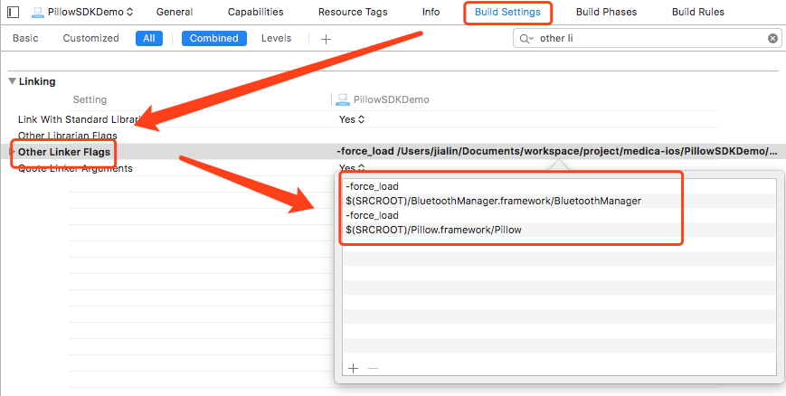

API

How to call method
#import <Pillow/Pillow.h>

[SLPBLESharedManager <method>]

eg: get the working status
[SLPBLESharedManager pillow:self.selectPeripheral.peripheral getCollectionStatusWithTimeout:10.0 callback:^(SLPDataTransferStatus status, id data) {
// do something
}];

1. Scan Bluetooth
- (BOOL)scanBluetoothWithTimeoutInterval:(CGFloat)timeOutInterval completion:(SLPBLEScanHandle)handle;

Description
Scan device

Parameters
SLPBLEScanHandle:
Field | Type | Description
code | SLPBLEScanReturnCodes | Need to be judged code == SLPBLEScanReturnCode_Normal frist  typedef NS_ENUM(NSInteger,SLPBLEScanReturnCodes) {  // Normal  SLPBLEScanReturnCode_Normal,  // BlueTooth is disable  SLPBLEScanReturnCode_Disable,  // Overtime  SLPBLEScanReturnCode_TimeOut,  };
handleID | int | The ID of this operation, ID use to stop scan
peripheralInfo | SLPPeripheralInfo | If code=SLPBLEScanReturnCode_Normal，response SLPPeripheralInfo

Stop Scan
- (void)stopScanHandle:(NSInteger)handleID;

Description
Stop scan

Parameters
Parameter | Type | Description
handleID | int | Get the handleID from “Scan Bluetooth” menthod

Connnect Device
- (void)pillow:(CBPeripheral *)peripheral loginWithDeviceName:(NSString *)deviceName
deviceCode:(NSString *)deviceCode
userId:(NSInteger)userId
callback:(SLPTransforCallback)handle;

Description
Connect Pillow and setting userId

Parameters
Parameter | Type | Description
deviceName | String | deviceName  from SLPPeripheralInfo’s name
deviceCode | String | deviceCode
userId | int | userId does not belong to Sleepace.  userId belong to partner  Why need it：  Pillow separates the data according to userId.  It mean user A connects to device, generates and gets the data which only belong to user A. User A can’t get the data of user B
handle | SLPTransforCallback | if success, return data = PillowDeviceInfo

Get Battery
- (void)pillow:(CBPeripheral *)peripheral getBatteryWithTimeout:(CGFloat)timeout
callback:(SLPTransforCallback)handle;

Description
Get battery

Parameters
Parameter | Type | Description
timeout | int | Timeout, Unit(second)
handle | SLPTransforCallback | if success, return data = PillowBatteryInfo

Get Device Version
- (void)pillow:(CBPeripheral *)peripheral getDeviceVersionWithTimeout:(CGFloat)timeout
callback:(SLPTransforCallback)handle;

Description
Get current version of device

Parameters
Parameter | Type | Description
timeout | int | Timeout, Unit(second)
handle | SLPTransforCallback | if success, return data = PillowDeviceVersion

Get Collection Status
- (void)pillow:(CBPeripheral *)peripheral getCollectionStatusWithTimeout:(CGFloat)timeout
callback:(SLPTransforCallback)handle;

Description
Get collection status, monitoring or not

Parameters
Parameter | Type | Description
timeout | int | Timeout, Unit(second)
handle | SLPTransforCallback | if success, return data = PillowCollectionStatus

Get Sleep Data (Real-time)
- (void)pillow:(CBPeripheral *)peripheral startRealTimeDataWithTimeout:(CGFloat)timeout
callback:(SLPTransforCallback)handle;

Description
Get Real-time Data

Parameters
Parameter | Type | Description
timeout | int | Timeout, Unit(second)
handle | SLPTransforCallback | Callback, you will get PillowRealTimeData from Notification

Notification
[[NSNotificationCenter defaultCenter]addObserverForName:kNotificationNameBLEPillowRealtimeData object:nil queue:[NSOperationQueue mainQueue] usingBlock:^(NSNotification * _Nonnull note) {
PillowRealTimeData *realData= [note.userInfo objectForKey:kNotificationPostData];
// do something
}];

Stop Getting Sleep Data
- (void)pillow:(CBPeripheral *)peripheral stopRealTimeDataWithTimeout:(CGFloat)timeout
callback:(SLPTransforCallback)handle;

Description
Stop getting real-time data

Parameters
Parameter | Type | Description
timeout | int | Timeout, Unit(second)
handle | SLPTransforCallback | Callback

Get The Signal Strength (Real-time)(Invalid)
- (void)pillow:(CBPeripheral *)peripheral startOriginalDataWithTimeout:(CGFloat)timeout
callback:(SLPTransforCallback)handle;

Description
Get the signal strength

Parameters
Parameter | Type | Description
timeout | int | Timeout, Unit(second)
handle | SLPTransforCallback | Callback, you will get PillowOriginalData from Notification

Notification
[[NSNotificationCenter defaultCenter]addObserverForName:kNotificationNameBLEPillowOriginalData object:nil queue:[NSOperationQueue mainQueue] usingBlock:^(NSNotification * _Nonnull note) {
PillowOriginalData *originaData= [note.userInfo objectForKey:kNotificationPostData];
// do something
}];

Stop Getting The Signal Strength(Invalid)
- (void)pillow:(CBPeripheral *)peripheral stopOriginalDataWithTimeout:(CGFloat)timeout
callback:(SLPTransforCallback)handle;

Description
Stop Getting The Signal Strength

Parameters
Parameter | Type | Description
timeout | int | Timeout, Unit(second)
handle | SLPTransforCallback | Callback

Get Sleep Report
- (void)autoPillow:(CBPeripheral *)peripheral personType:(SLPSleepPersonTypes)type
historyDownloadWithStartTime:(NSInteger)startTime
endTime:(NSInteger)endTime
eachDataCallback:(SLPTransforCallback)eachhandle
finishCallback:(SLPTransforCallback)finishHandle

Description
Get sleep report

Parameters
Parameter | Type | Description
starTime | int | Start time(timestamp)
endTime | int | End time(timestamp)
type | SLPSleepPersonTypes | gender
timeout | int | Timeout, Unit(second)
eachhandle | SLPTransforCallback | Callback when get one data，if success, return data=SLPHistoryData
finishHandle | SLPTransforCallback | Callback when got all data.

Firmware Update
- (void)pillow:(CBPeripheral *)peripheral upgradeDeviceWithCrcDes:(long)crcDes
crcBin:(long)crcBin
upgradePackage:(NSData *)package
callback:(SLPTransforCallback)handle;

Description
Firmware Update

Parameters
Parameter | Type | Description
crcDes | long | Get it from Sleepace
crcBin | long | Get it from Sleepace
package | NSData | Get it from Sleepace
handle | SLPTransforCallback | if success, return data=PillowUpgradeInfo

Get environment data （invalid）
-(void)pillow:(CBPeripheral *)peripheral getEnvironmentalDataTimeout:(CGFloat)timeout completion:(SLPTransforCallback)handle;

Description
Get environment data

Parameters
Parameter | Type | Description
handle | SLPTransforCallback | if success, return data=PillowUpgradeInfo

Object definition

DeviceCode
字段 | Description
46-0 | P200A device

SLPTransforCallback

Description
Callback of all monthods

Method
typedef void(^SLPTransforCallback)(SLPDataTransferStatus status,id data);

Parameters
Filed | Type | Description
status | SLPDataTransferStatus | SLPDataTransferStatus
data | id | If status = SLPDataTransferReturnStatus_Succeed, data is available. See the method reference you will know how to change the data to the object you need.

SLPDataTransferStatus
Filed | Value | Description
SLPDataTransferStatus_Succeed | 0 | Success
SLPDataTransferStatus_ConnectionDisconnected | 1 | disconnected
SLPDataTransferStatus_TimeOut | 2 | Timeout
SLPDataTransferStatus_Failed | 3 | Failed
SLPDataTransferStatus_ConnectionDisabled | 4 | Bluetooth disabled
SLPDataTransferStatus_ParameterError | 5 | Parameter error

SLPPeripheralInfo

Description
The result of scanning bluetooth

Fields
字段 | Type | Description
peripheral | CBPeripheral | Bluetooth reference
name | String | deviceName

PillowDeviceInfo

Descrption
The result of Connnect Device.

Fields
字段 | Type | Description
hardwareVersion | String | Device version
deviceId | String | Device ID

PillowBatteryInfo

Description
The result of getting battery

Fields
Field | Type | Description
chargingState | int | Charging or not，  0：not  1: charging
quantity | int | Percentage of battery, It’s disable when charging

PillowDeviceVersion

Description
The result of getting device version

Fields
Field | Type | Description
hardwareVersion | String | version

PillowCollectionStatus

Description
The result of getting collection status

Fields
Field | Type | Description
collectionStatus | Int | Collection status  1:Collecting，0：not
isCollecting | BOOL | Collecting or not  YES: Collecting  NO: not

PillowRealTimeData

Description
The result of getting sleep data (Real-time)

Fields
Field | Type | Description
heartRate | short | Heart rate
breathRate | short | breathPauseAllTime rate
status | int | 0: Normal  1: init  2: apnea  3: Heartbeat pause  4: Body movement  5: Leaving bed  6: Turning over
statusValue | int | The value of status. Unit(second)
sleepFlag | BOOL | Asleep or not  YES: asleep  NO: not
wakeFalg | BOOL | Awake or not  YES: awake  NO: not
isOffBed | BOOL | Leave bed  YES: leave bed  NO:
isInit | BOOL | Init or not  YES: init  NO: not
Temperture（invalid） | Int | temperture
humidity（invalid） | Int | humidity

PillowOriginalData

Description
The result of getting signal strength

Fields
Field | Type | Description
heartRate | Float[] | Heart rate
breathRate | Float[] | Breath rate

SLPHistoryData

Description
The result of getting sleep reprot

Fields
Field | Type | Description
summary | HistoryDataSummary | Summary  HistoryDataSummary
detail | HistoryDataDetail | Detail  HistoryDataDetail
analy | HistoryDataAnalysis | Analysis  HistoryDataAnalysis

HistoryDataSummary

Description
Summary of sleep report

Fields
Field | Type | Description
recordCount | int | The length of Collecting.  Unit(minute)  Eg:  300. It means you collect for 300 minutes
startTime | int | Start time(timestamp). Unit(second)
stopMode | int | How to stop collecting：  0: Call the method “Stop Collecting”  1: stop automatically if you leave the bed for an hour  2: Error(a、Collect more than 24 hours，b、pillow shutdown c、upgrade)  3: restart

HistoryDataDetail

Description
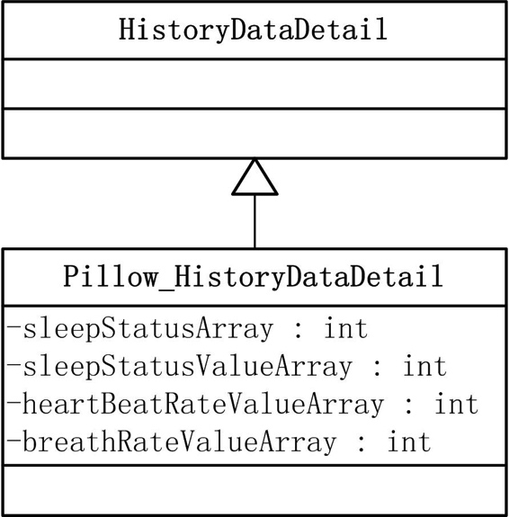

Pillow_HistoryDataDetail *detail =(Pillow_HistoryDataDetail *)historyData.detail;
P300_HistoryDataDetail *detail =(P300_HistoryDataDetail *)historyData.detail;

Fields
Field | Type | Description
breathRateValueArray | int[] | Breath rate
heartBeatRateValueArray | int[] | Heart rate
sleepStatusArray | int[] | Status
sleepStatusValueArray | int[] | The value of status

HistoryDataAnalysis

Description
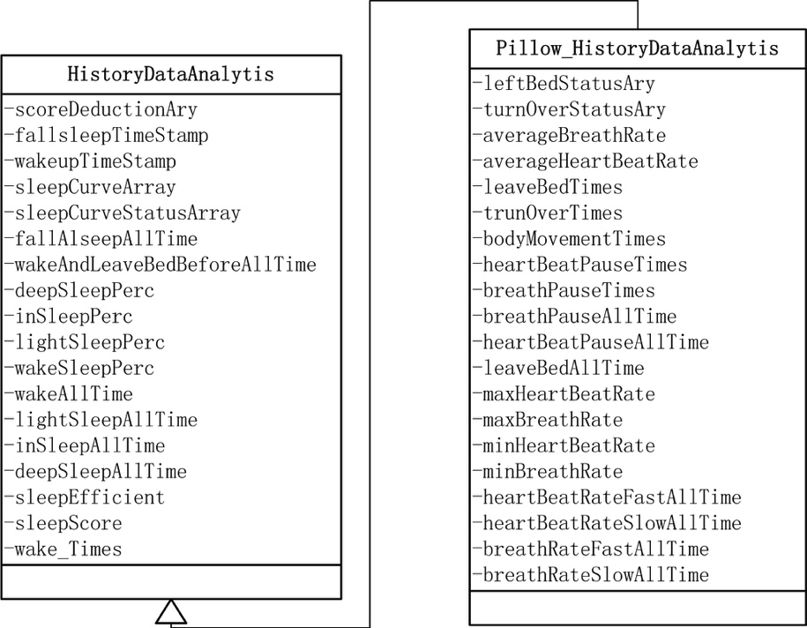

Pillow_HistoryDataAnalysis *analysis=(Pillow_HistoryDataAnalysis *)historyData.analytis;

Fields
Fields | Type | Description
averageBreathRate | int | Average breath rate(n counts per min)
averageHeartBeatRate | int | Average heart rate(n counts per min)
fallAlseepAllTime | int | Fall asleep time(Unit:min)
wakeAndLeaveBedBeforeAllTime | int | Duration of awake before getting up(Unit:min)
leaveBedTimes | int | Counts of leaving bed
trunOverTimes | int | Counts of turning over
bodyMovementTimes | int | Counts of body movement
heartBeatPauseTimes | int | Counts of Heat beat Pause
breathPauseTimes | int | Counts of apnea
deepSleepPerc | int | Deep sleep percentage
inSleepPerc | int | Mid sleep percentage
lightSleepPerc | int | Light sleep percentage
wakeSleepPerc | int | Awake percentage
duration | int | Sleep duration(Unit:min)
wake_Times | int | Awake times
lightSleepAllTime | int | Duration of Light sleep(Unit:min)
inSleepAllTime | int | Duration of Mid sleep(Unit:min)
deepSleepAllTime | int | Duration of Deep sleep)(Unit:min)
wakeAllTime | int | Duration of Awake)(Unit:min)
breathPauseAllTime | int | Duration of Apnea(Unit:seconds)
heartBeatPauseAllTime | int | Duration of heart beat pause)(Unit:seconds)
leaveBedAllTime | int | Duration of leaving bed(Unit:min)
maxHeartBeatRate | int | Maximum heart rate(n counts per min)
maxBreathRate | int | Maximum breath rate(n counts per min)
minHeartBeatRate | int | Minimum heart rate)(n counts per min)
minBreathRate | int | Minimum breath rate(n counts per min)
heartBeatRateFastAllTime | int | Duration of tachycardia(Unit:seconds)
heartBeatRateSlowAllTime | int | Duration of bradycardia(Unit:seconds)
breathRateFastAllTime | int | Duration of tachypnea(Unit:seconds)
breathRateSlowAllTime | int | Duration of bradypnea(Unit:seconds)
sleepScore | int | Score  90>=score<=100 Bravo!  80>=score<90 Good!  60>=score<80, average!  score <60 Bad
sleepCurveArray | float[] | Example:  [0.212,1.231,2.111,0.212,1.231,2.111,....]  Drawing sleep curve (Unit:min)  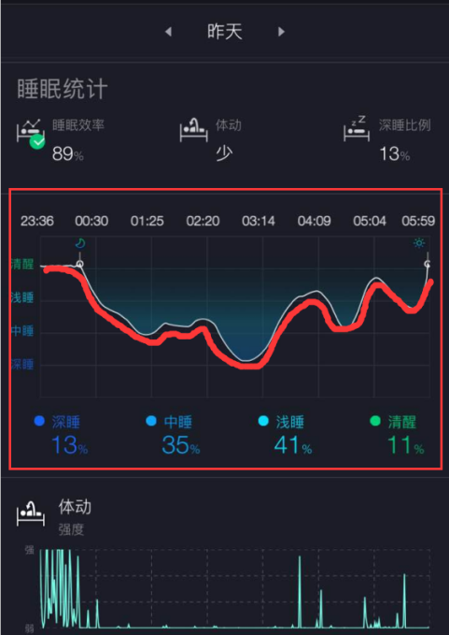
sleepCurveStatusArray | short[] | Sleep Event Flag (Unit:min)
algorithmVer | String | Algorithm version
fallsleepTimeStamp | int | The time you fall asleep(timestamp)
wakeupTimeStamp | int | The time you wake up(timestamp)
reportFlag | int | - Long report(>3h)  - Short report(>10m && <3h)
scoreDeductionAry | Array<HistoryDataScoreDeduction> | Score Deduction HistoryDataScoreDeduction
breathRateStatusAry | int[] | Apnea, It used to draw the graph  Example:  [0,0,1,0,2]  0: nothing  Other: Duration of Apnea in this minute(Unit:seconds)
heartRateStatusAry | int[] | Heart beat pause, It used to draw the graph  Example:  [0,0,1,0,2]  0: nothing  Other: Duration of Heat beat Pause in this minute(Unit:seconds)
leftBedStatusAry | int[] | Leave bed, It used to draw the graph  Example:  [0,0,1,0,2]  0: nothing  Other: Duration of leaving bed in this minute(Unit:seconds)
turnOverStatusAry | int[] | Turn over, It used to draw the graph  Example:  [0,0,1,0,2]  0: nothing  Other: the times of turning over

HistoryDataScoreDeduction

Description
Deduction

Fields
Field | Type | Description
type | int | The type of deduction.  See the Detail of  Pillow_ScoreDeductibleTypes
score | int | The value of deduction

Pillow_ScoreDeductibleTypes

Description
Score Deduction

Fields
Field | Type | Description
Pillow_ScoreDeductibleType_BodyMoveToomuch | Int | Score Deduction due to body movement
Pillow_ScoreDeductibleType_LeftBedToomany | Int | Score Deduction due to the times of leaving bed
Pillow_ScoreDeductibleType_AwakeTooFrequent | Int | Score Deduction due to the wake count
Pillow_ScoreDeductibleType_SleepToolate | Int | Score Deduction due to sleeping time (too late)
Pillow_ScoreDeductibleType_DifficultToSleep | Int | Score Deduction due to long falling sleep time
Pillow_ScoreDeductibleType_DeepSleepNotEnough | Int | Score Deduction due to the deep sleep
Pillow_ScoreDeductibleType_SleepTooLong | Int | Score Deduction due to sleeping time too long
Pillow_ScoreDeductibleType_SleepTooShort | Int | Score Deduction due to sleeping time too short
Pillow_ScoreDeductibleType_BreathPause | Int | Score Deduction due to breathing stop
Pillow_ScoreDeductibleType_HeartbeatPause | Int | Score Deduction due to Heart beat stop
Pillow_ScoreDeductibleType_HeartbeatLow | Int | Score Deduction due to slow heart beat
Pillow_ScoreDeductibleType_HeartbeatHigh | Int | Score Deduction due to Rapid heart beat
Pillow_ScoreDeductibleType_BreathLow | Int | Score Deduction due to slow breathing
Pillow_ScoreDeductibleType_BreathHight | Int | Score Deduction due to rapid breathing
Pillow_ScoreDeductibleType_optimumSleepPercentTooLow | Int | Score Deduction due to good sleeping (ratio of middle sleep/deep sleep)
Pillow_ScoreDeductibleType_Invalid, | Int | invalid

PillowUpgradeInfo

Description
The result of firmware update

Fields
Field | Type | Description
process | float | The percentage of upgrade

